**2. spring-rest-handson**

**1. Hello World RESTful Web Service**   
**Code:**

SpringLearn1Application.java

**package** com.cognizant.springlearn1;

**import** org.springframework.boot.SpringApplication;

**import** org.springframework.boot.autoconfigure.SpringBootApplication;

@SpringBootApplication

**public** **class** SpringLearn1Application {

**public** **static** **void** main(String[] args) {

SpringApplication.*run*(SpringLearn1Application.**class**, args);

}

}

HelloController.java

**package** com.cognizant.springlearn1.controller;

**import** org.slf4j.Logger;

**import** org.slf4j.LoggerFactory;

**import** org.springframework.web.bind.annotation.GetMapping;

**import** org.springframework.web.bind.annotation.RestController;

@RestController

**public** **class** HelloController {

**private** **static** **final** Logger ***logger*** = LoggerFactory.*getLogger*(HelloController.**class**);

@GetMapping("/hello")

**public** String sayHello() {

***logger***.info("Start - sayHello() method called");

String response = "Hello World!!";

***logger***.info("End - sayHello() method executed successfully");

**return** response;

}

}

Application.properties

# Server Configuration

server.port=8083

# Logging Configuration

logging.level.com.cognizant.spring_learn=INFO

logging.pattern.console=%d{yyyy-MM-dd HH:mm:ss} - %msg%n

**output:**

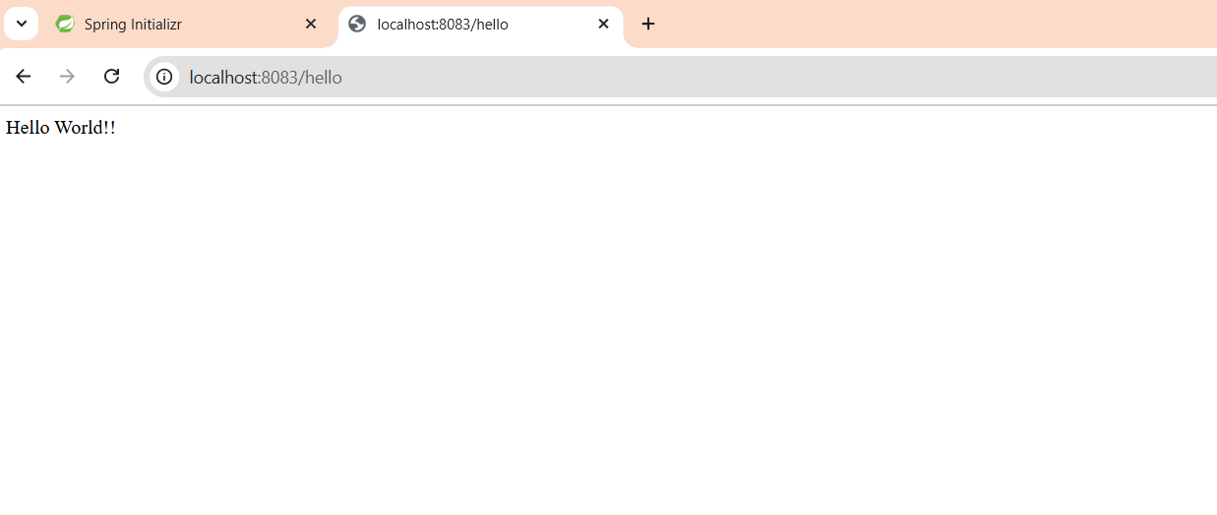

**2. REST - Country Web Service**

**Code:**

SpringLearn2Application.java

**package** com.cognizant.spring_learn2;

**import** org.springframework.boot.SpringApplication;

**import** org.springframework.boot.autoconfigure.SpringBootApplication;

**import** org.springframework.context.annotation.ImportResource;

@SpringBootApplication

@ImportResource("classpath:applicationContext.xml")

**public** **class** SpringLearn2Application {

**public** **static** **void** main(String[] args) {

SpringApplication.*run*(SpringLearn2Application.**class**, args);

}

}

Country.java

**package** com.cognizant.spring_learn2.model;

**public** **class** Country {

**private** String code;

**private** String name;

// Default constructor

**public** Country() {

}

// Parameterized constructor

**public** Country(String code, String name) {

**this**.code = code;

**this**.name = name;

}

// Getters and Setters

**public** String getCode() {

**return** code;

}

**public** **void** setCode(String code) {

**this**.code = code;

}

**public** String getName() {

**return** name;

}

**public** **void** setName(String name) {

**this**.name = name;

}

@Override

**public** String toString() {

**return** "Country{" +

"code='" + code + '\'' +

", name='" + name + '\'' +

'}';

}

}

CountryController.java

**package** com.cognizant.spring_learn2.controller;

**import** com.cognizant.spring_learn2.model.Country;

**import** org.slf4j.Logger;

**import** org.slf4j.LoggerFactory;

**import** org.springframework.context.ApplicationContext;

**import** org.springframework.context.support.ClassPathXmlApplicationContext;

**import** org.springframework.web.bind.annotation.RequestMapping;

**import** org.springframework.web.bind.annotation.RequestMethod;

**import** org.springframework.web.bind.annotation.RestController;

@RestController

**public** **class** CountryController {

**private** **static** **final** Logger ***logger*** = LoggerFactory.*getLogger*(CountryController.**class**);

@RequestMapping(value = "/country", method = RequestMethod.***GET***)

**public** Country getCountryIndia() {

***logger***.info("Start - getCountryIndia() method called");

// Load Spring XML configuration

ApplicationContext context = **new** ClassPathXmlApplicationContext("applicationContext.xml");

// Get India bean from Spring container

Country indiaCountry = (Country) context.getBean("indiaCountry");

***logger***.info("Country details loaded: {}", indiaCountry);

***logger***.info("End - getCountryIndia() method executed successfully");

**return** indiaCountry;

}

}

**Output:**

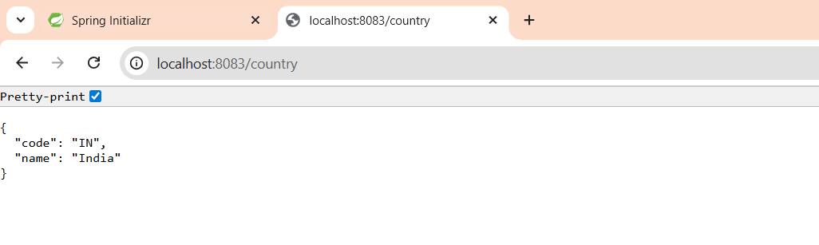

**3. REST - Get country based on country code**

**Code:**

SpringLearn3Application.java

**package** com.cognizant.spring_learn3;

**import** org.springframework.boot.SpringApplication;

**import** org.springframework.boot.autoconfigure.SpringBootApplication;

**import** org.springframework.context.annotation.ImportResource;

@SpringBootApplication

@ImportResource("classpath:country.xml")

**public** **class** SpringLearn3Application {

**public** **static** **void** main(String[] args) {

SpringApplication.*run*(SpringLearn3Application.**class**, args);

}

}

CountryController .java

**package** com.cognizant.spring_learn3.controller;

**import** com.cognizant.spring_learn3.model.Country;

**import** com.cognizant.spring_learn3.service.CountryService;

**import** org.springframework.beans.factory.annotation.Autowired;

**import** org.springframework.http.ResponseEntity;

**import** org.springframework.web.bind.annotation.*;

@RestController

@RequestMapping("/country")

**public** **class** CountryController {

@Autowired

**private** CountryService countryService;

/**

* Get country based on country code (case insensitive)

* **@param** code - country code from path variable

* **@return** Country object as JSON response

*/

@GetMapping("/countries/{code}")

**public** ResponseEntity<Country> getCountry(@PathVariable String code) {

// Invoke countryService.getCountry(code)

Country country = countryService.getCountry(code);

**if** (country != **null**) {

**return** ResponseEntity.*ok*(country);

} **else** {

**return** ResponseEntity.*notFound*().build();

}

}

/**

* Alternative endpoint that matches the sample request format

* **@param** code - country code from path variable

* **@return** Country object as JSON response

*/

@GetMapping("/{code}")

**public** ResponseEntity<Country> getCountryAlternative(@PathVariable String code) {

Country country = countryService.getCountry(code);

**if** (country != **null**) {

**return** ResponseEntity.*ok*(country);

} **else** {

**return** ResponseEntity.*notFound*().build();

}

}

}

Country.java

**package** com.cognizant.spring_learn3.model;

**public** **class** Country {

**private** String code;

**private** String name;

// Default constructor

**public** Country() {

}

// Parameterized constructor

**public** Country(String code, String name) {

**this**.code = code;

**this**.name = name;

}

// Getters and Setters

**public** String getCode() {

**return** code;

}

**public** **void** setCode(String code) {

**this**.code = code;

}

**public** String getName() {

**return** name;

}

**public** **void** setName(String name) {

**this**.name = name;

}

@Override

**public** String toString() {

**return** "Country{" +

"code='" + code + '\'' +

", name='" + name + '\'' +

'}';

}

}

**Output:**

